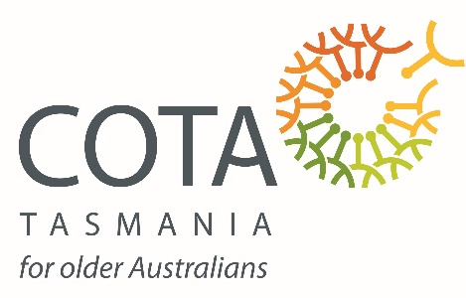
Piecing it Together – Key information
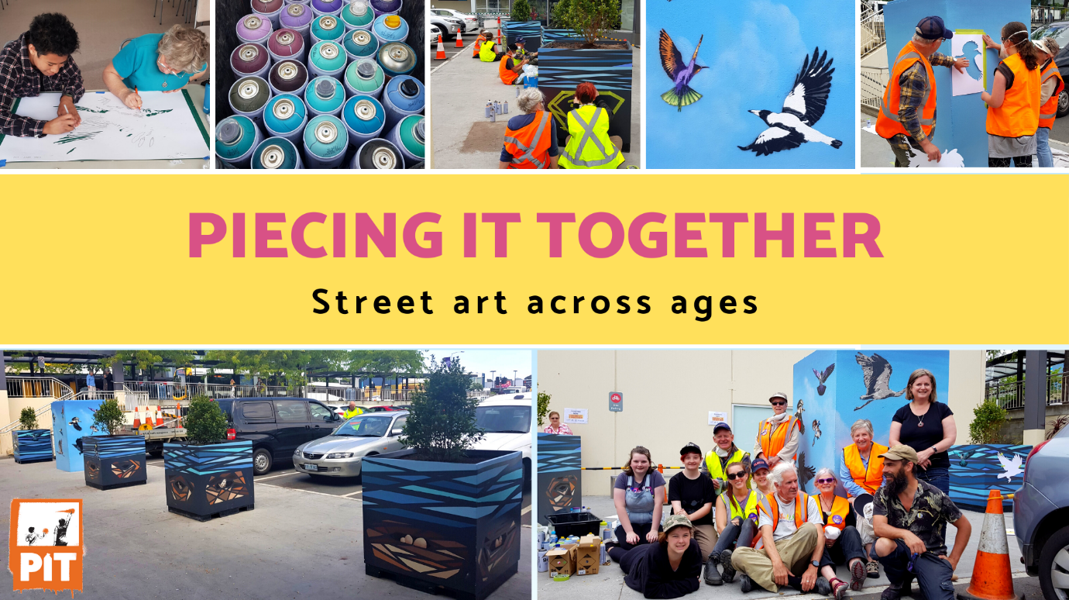

What is Piecing it Together?
Piecing it Together is a project in which younger and older people work together to learn about, design, and create street art. It aims to challenge stereotypes about being younger and becoming older. No art experience is needed for the project - just a desire to learn and work with others.
Piecing it Together will be managed by COTA Tasmania and is a partnership between local councils or community organisations. Artistic work will be led by a Tasmanian artist and the previous 3 PiT has been with Jamin, known for his vibrant murals and street art as well as his contemporary approaches to visual art.

Contact COTA Tasmania for more information or to schedule a conversation about PiT in your area:
Brigidw@cotatas.org.au / 62 313 265
What does Piecing it Together involve?
Piecing it Together includes:
- A three-day co design workshop
- Three days on-site painting
- Follow up lunch with participants
Piecing it Together is usually filmed and photographed for promotion and reporting, but you can be excluded from this by indicating that you do not want to be filmed or photographed in your Media Consent form.
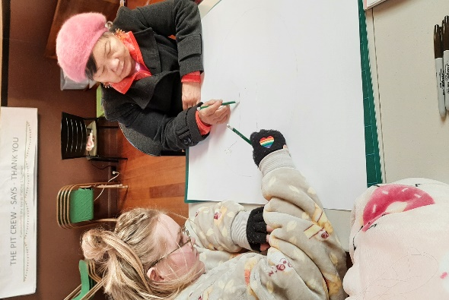
What do I need to express an interest in Piecing it Together?
Complete the Checklist on the last page of this document to make sure you’ve done everything to prepare for Piecing it Together.
To be part of Piecing it Together, you must:
- Be aged between 13 and 18 years (and have parental/carer consent to participate), or aged over 60 years;
- Be able to attend the three-day workshop and three days of on-site painting, (dates as stated within this document).
There are a few documents you have to read and understand to make sure you know what to expect during Piecing it Together. These include:
- This Explanatory Statement, which explains what will happen and information you need to know;
- The Media Consent form, which gives permission to use your image and words in videos and photos in Piecing it Together for promotion and reporting;

- The Informed Consent form (for participants aged under 18), in which parents or carers give permission for their child to participate in Piecing it Together.
What is involved during Piecing it Together?
Participants need to organise travel to and from the Piecing it Together project site (let us know if you have trouble with this). Lunch is usually provided each day as well as morning tea. Please bring your own water bottle/drinks.
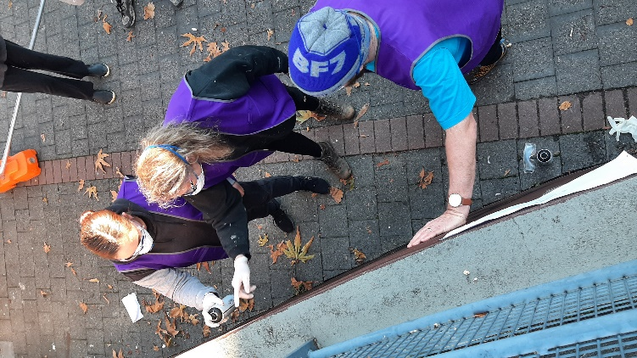
All safety and art equipment will be provided and participants are encouraged to wear old clothes on painting days.
To make sure Piecing it Together meets its goals and can improve, participants will be asked to complete two quick surveys - one during the workshop week and one towards the end of the project. We’d love participants to let us know how they found the experience and we therefore like to meet for a shared lunch a few months after the project.
Once the project has commenced, please contact COTA as soon as possible if you are unable to attend a day on Piecing it Together or if you have any issues with the above requirements.
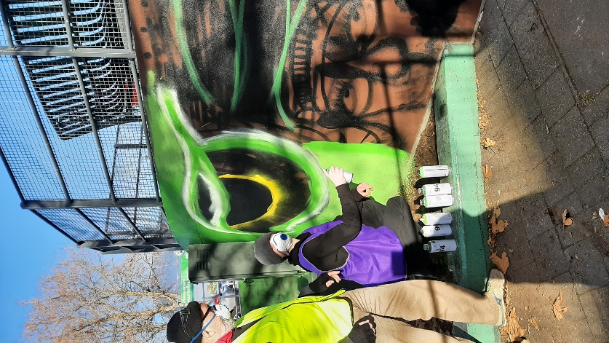
How will video and photos be used?
Piecing it Together will be filmed and photographed for project promotion and reporting. Video and photos may be used on COTA Tasmania and newsletters, websites, social media publications, or through broader media (television, radio etc.). You can request that you or your child’s image and/or words not be used in filming and photography through the Media Consent form and by talking to COTA Tasmania staff.
Are there any safety issues I should know about?
Piecing it Together may involve painting in an area shared by pedestrians and slow moving cars. Traffic and safety management plans will be developed as needed, alongside risk assessments and COTA staff will carefully watch participants to make sure everyone stays safe throughout.
Procedures in the case of an emergency will be developed with COTA Tasmania and partnering organisations.
Piecing it Together Checklist
Complete this Checklist to make sure you are ready for Piecing it Together!
- I am aged 60 years or over, or 13 to 18 years with parental/carer consent to participate in Piecing it Together.
- I can attend the 3 workshop days and the 3 on-site painting days
- I and my parent/carer (if applicable) have read and understood this Piecing it Together – Explanatory Statement document.
- I and my parent/carer (if applicable) have read, understood and signed the Media Consent form for use of my image and words in photographs, videos, audio and transcripts.
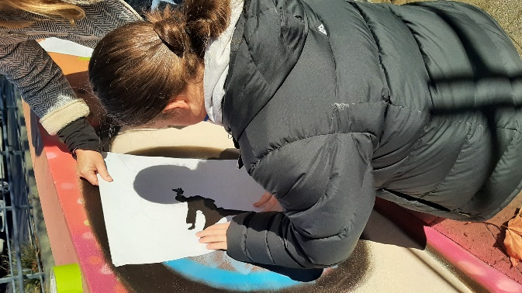

- (For participants aged under 18 years) My parent/carer has read, understood and signed the Informed Consent form.
- (For participants aged over 18 years) I have provided COTA Tasmania details of my current Working With Vulnerable Peoples card (volunteer or employed), if I have this.

Now you are ready to complete the Registration form!

- School participants – please provide all completed forms to your school contact who will forward to COTA Tasmania.

- Adult participants - Please ensure all completed forms are provided to COTA Tasmania: brigidw@cotatas.org.au ahead of the workshop dates.

